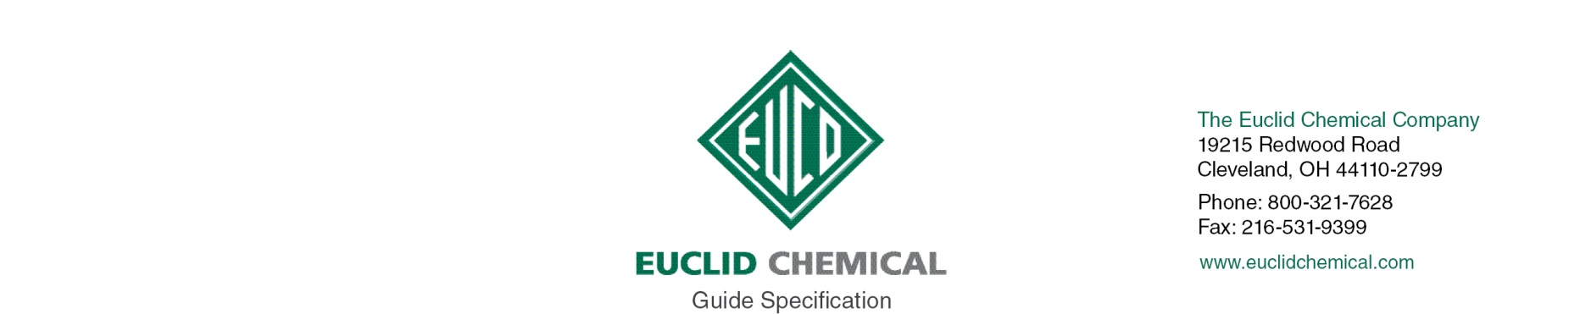
TAMMSFLEX NS & TAMMSFLEX SL
NSF Approved Two Part Polysulfide Sealant for Joints and Cracks

{Note to Specifier: The paragraphs below are meant to be incorporated into Parts 2 and 3 of a standard CSI 3 Part Format specification, the General Structural Notes, or directly onto the plans. They must be carefully reviewed by a qualified design professional and edited to meet the requirements of the project and governing building codes. Coordinate with other specification sections and drawings.}

PART 2: PRODUCT

2.__ SEALANT

A. NSF approved, polysulfide, two part, elastomeric, caulking and sealing compound available in non-sag and self-leveling formulations.
1. Meets ASTM C 920
2. Meets NSF Standard 61
3. Shore A Hardness: 25-35
4. % Joint Movement: +/- 25
5. % Elongation: 500 to 550
6. Acceptable Products:
a) Tammsflex NS and Tammsflex SL by The Euclid Chemical Company, www.euclidchemical.com

2.__ MANUFACTURER

A. Manufacturer shall have ISO 9001 Quality Certification. To ensure compatibility all products shall be from the same manufacturer.

PART 3- EXECUTION

3.__ SURFACE PREPARATION

A. Prepare joints and cracks per manufacturer’s written instructions.

B. Surfaces of the joints and cracks shall be clean, sound and dry. Contaminants such as previously applied sealants, form releases agents, grease, oil, etc. shall be removed. Dust shall be blown out of the joints and cracks with oil free, moisture free compressed air.

3.__ SEALANT APPLICATION

A. Mix and install sealant per manufacturer’s written instructions.

